TECHNOLOGY ARCHITECTURE

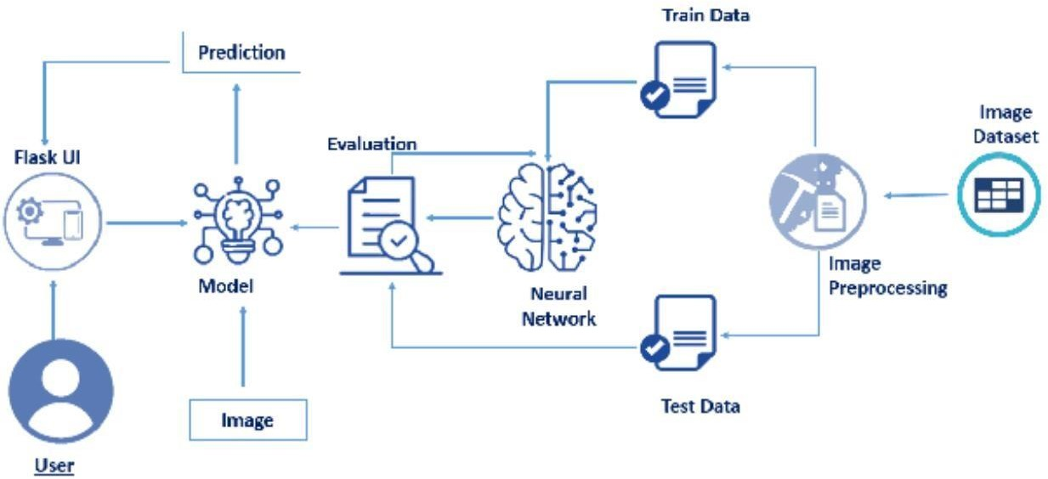 **TEAM ID :** PNT2022TMID31860